
DETAILED EXPLANATORY NOTES

GENETICS AND MOLECULAR BIOLOGY
DNA STRUCTURE

GRADE 12- BIOLOGY

■ ■ ■

What is Molecular Biology?
Molecular biology is the branch of biology that studies life at the molecular level, focusing on the molecules responsible for storing, transmitting, and expressing genetic information. The most important of these molecules are deoxyribonucleic acid (DNA), ribonucleic acid (RNA), and proteins, which work together to control the structure, function, growth, and reproduction of living organisms.
Molecular biology seeks to explain how a single molecule of DNA can contain the complete set of instructions needed to build and maintain an organism. It investigates how genetic information is stored within DNA, copied during cell division, and used to produce proteins that perform essential cellular functions.
Advances in molecular biology have transformed modern science, providing a deeper understanding of heredity, evolution, disease, biotechnology, agriculture, and medicine. Knowledge of molecular biology allows scientists to study genes, develop new medical treatments, improve crop varieties, and explore the genetic diversity of living organisms.

The Branches of Molecular Biology
Modern molecular biology is organized into several interconnected areas of study:
- Structure of Biomolecules - examines the composition and structure of DNA, RNA, proteins, and other biological molecules.
- The Central Dogma - investigates the flow of genetic information through DNA replication, transcription, and translation.
- Genomics - studies the complete set of genetic material (genome) within an organism.
- Gene Regulation - explores how genes are switched on and off in response to cellular and environmental conditions.
- Recombinant DNA Technology - involves the cutting, joining, and transfer of genes for research, medicine, and biotechnology.
- Bioinformatics - uses computer science, mathematics, and data analysis to store, manage, and interpret biological information.
Together, these branches help scientists understand how genetic information controls life processes and how molecular knowledge can be applied to solve biological and technological challenges.

DNA Structure

Key Learning Outcomes
By the end of this lesson, students should be able to:
- Define a nucleic acid and identify DNA and RNA as the two major nucleic acids found in living organisms.
- Describe the structure of a nucleotide and distinguish between a nucleotide and a nucleoside.
- Identify and classify the four nitrogenous bases of DNA as purines (adenine and guanine) or pyrimidines (cytosine and thymine).
- Describe the structure of the DNA double helix, including the sugar–phosphate backbone, complementary base pairing, antiparallel strands, and the 5′ and 3′ ends.
- Explain the rules of complementary base pairing and the role of hydrogen bonds in maintaining the structure of DNA.
- Describe how DNA is packaged into chromosomes through its association with histone proteins and chromatin.
- Compare the structure and function of DNA and RNA, highlighting their similarities and differences.
- Explain why the structure of DNA is well suited to its role as the genetic material, including information storage, replication, and inheritance.

What is a Nucleic Acid?
Every living organism carries a complete set of biological instructions written in molecules known as nucleic acids. These molecules serve as the carriers of genetic information and are responsible for storing, transmitting, and helping express the instructions needed for life. Nucleic acids play a central role in growth, development, reproduction, and the functioning of cells.
Nucleic acids are large biological molecules composed of repeating units called nucleotides. Because they consist of many linked nucleotides, they are described as polymers. The sequence of nucleotides within a nucleic acid molecule forms a genetic code that contains the information required to build proteins and regulate cellular activities.
There are two major types of nucleic acids found in living organisms:
- Deoxyribonucleic Acid (DNA) - the long-term storage molecule that contains the genetic blueprint of an organism.
- Ribonucleic Acid (RNA) - a molecule involved in transferring and using genetic information to produce proteins.
Together, DNA and RNA enable the storage, copying, and expression of genetic information, forming the foundation of heredity and molecular biology.
The modern understanding of DNA emerged through the work of several scientists. In 1953, James Watson and Francis Crick proposed the double-helix model of DNA, building on the X-ray diffraction studies of Rosalind Franklin and the base-pairing observations of Erwin Chargaff. This discovery revolutionized biology by revealing how genetic information could be stored and accurately passed from one generation to the next.
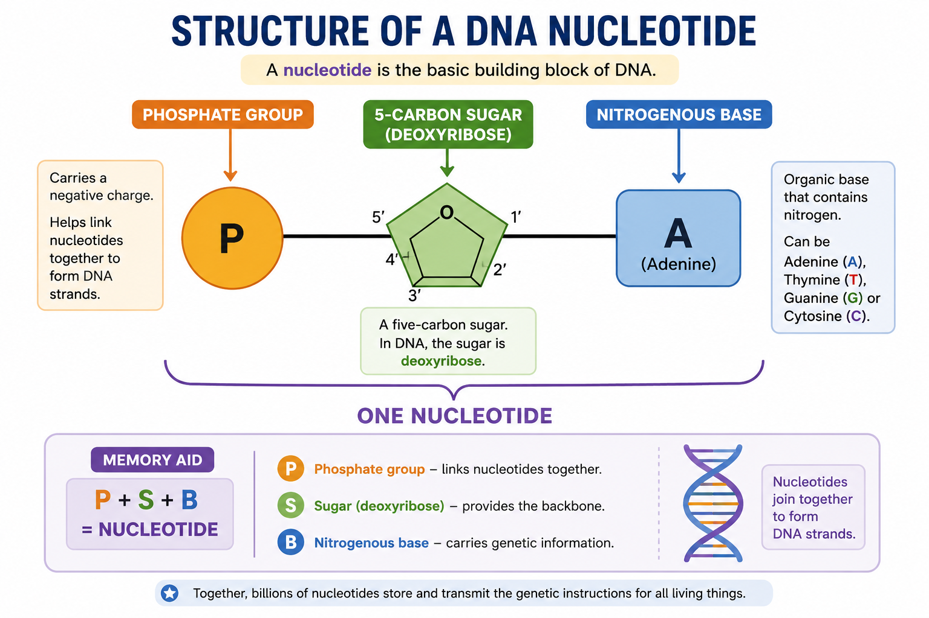

Figure 1: The structure of a nucleotide - a phosphate group, a five-carbon sugar and a nitrogenous base.

DNA Structure - Terminologies and Concepts
The study of DNA involves several important terms that help explain how genetic information is stored and transmitted within living organisms. Understanding these concepts provides the foundation for learning about DNA structure, replication, and gene expression.
- Nucleotide: The basic building block of nucleic acids. Each nucleotide consists of a phosphate group, a five-carbon sugar, and a nitrogenous base.
- Nucleoside: A molecule composed of a nitrogenous base attached to a sugar molecule, but without a phosphate group.
- Purines: Nitrogenous bases with a double-ring structure. The purines found in DNA are adenine (A) and guanine (G).
- Pyrimidines: Nitrogenous bases with a single-ring structure. The pyrimidines found in DNA are cytosine (C) and thymine (T). In RNA, uracil (U) replaces thymine.
- Double Helix: The characteristic twisted ladder structure formed by two DNA strands wound around each other.
- Antiparallel: The arrangement of DNA strands in opposite directions, with one strand running from 5′ to 3′ and the other from 3′ to 5′.
- Complementary Base Pairing: The specific pairing of nitrogenous bases in DNA where adenine always pairs with thymine and guanine always pairs with cytosine.
Understanding these terms helps explain how DNA stores information, maintains stability, and replicates accurately during cell division.

The Nucleotide - The Building Block of Life
Nucleotides are the fundamental building blocks of nucleic acids and are responsible for carrying genetic information. Each nucleotide is composed of three components:
- A phosphate group
- A five-carbon sugar (pentose sugar)
- A nitrogenous base
In DNA, the sugar is deoxyribose, while in RNA it is ribose. The phosphate group contributes to the acidic nature of nucleic acids and helps link neighboring nucleotides together.
The carbon atoms within the sugar molecule are numbered from 1′ to 5′. The nitrogenous base is attached to the 1′ carbon, while the phosphate group is attached to the 5′ carbon. This arrangement gives nucleic acid strands a specific direction, known as the 5′ to 3′ orientation.
When nucleotides join together, the phosphate group of one nucleotide forms a bond with the sugar of the next nucleotide, creating a repeating sugar–phosphate backbone. This backbone provides structural support for DNA and RNA molecules.

The Four Letters - The Nitrogenous Bases
The genetic information of all living organisms is encoded using four nitrogenous bases that form the molecular alphabet of DNA:
- Adenine (A)
- Thymine (T)
- Guanine (G)
- Cytosine (C)
These bases are grouped into two categories:
Purines | Pyrimidines
Adenine (A) | Cytosine (C)
Guanine (G) | Thymine (T)

Purines contain a double-ring structure, whereas pyrimidines contain a single-ring structure. In RNA, uracil (U) replaces thymine.
Although only four bases exist, the sequence in which they occur can produce an enormous variety of genetic information. The order of bases along a DNA strand forms the genetic code that determines the structure and function of proteins.

The DNA Double Helix
DNA consists of two long strands of nucleotides that wind around each other to form a structure known as the double helix. This structure resembles a twisted ladder, with each component contributing to its stability and function.
The outer sides of the ladder are formed by the sugar–phosphate backbones, while the rungs consist of paired nitrogenous bases held together by hydrogen bonds. The bases face inward, protecting the genetic information stored within the molecule.
The two strands are antiparallel, meaning they run in opposite directions. One strand extends from 5′ to 3′, while the complementary strand runs from 3′ to 5′. This arrangement is essential for DNA replication and other cellular processes.
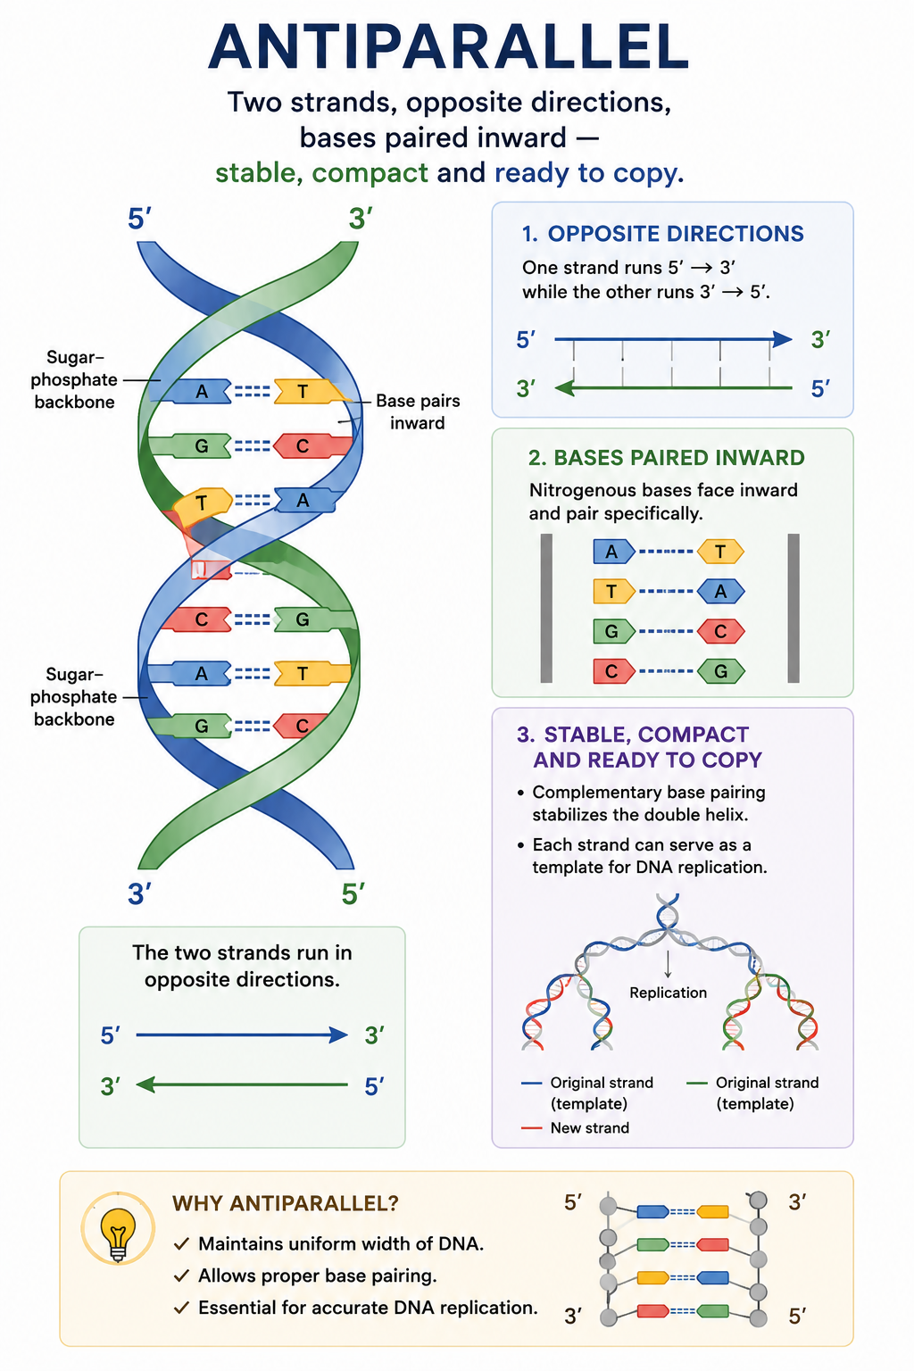
The double-helix structure allows DNA to store large amounts of genetic information while maintaining stability and enabling accurate copying of genetic material during cell division.
Figure 2: The DNA double helix - two antiparallel strands coiled around a common axis.

Why is DNA an Effective Information Storage Molecule?
DNA is exceptionally well-suited to its role as the genetic material. The sequence of nitrogenous bases stores vast amounts of biological information, while the double-helix structure protects this information from damage. Complementary base pairing enables DNA to be copied accurately during replication, ensuring that genetic information can be passed from one generation of cells to the next.
DNA is also chemically stable, allowing genetic information to be stored for long periods while remaining accessible when needed for cellular processes. These characteristics make DNA an efficient and reliable information-storage molecule for all living organisms.
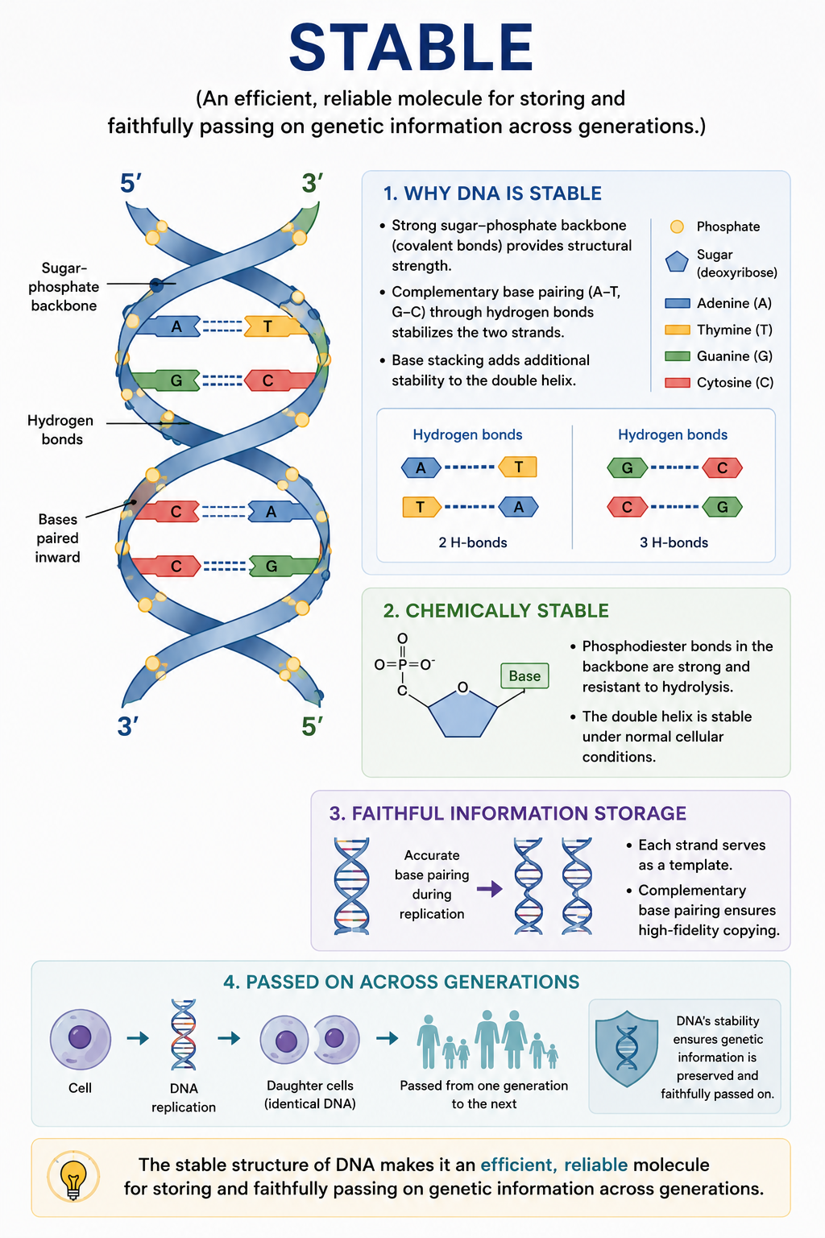
Figure 3: Structural features that make DNA a stable and reliable carrier of genetic information.

The Rules of Base Pairing
The structure of DNA is maintained by a precise system known as complementary base pairing. In DNA, the nitrogenous bases pair in a specific and predictable manner: adenine (A) always pairs with thymine (T), while guanine (G) always pairs with cytosine (C).
These base pairs are held together by hydrogen bonds. Adenine and thymine are connected by two hydrogen bonds, whereas guanine and cytosine are connected by three hydrogen bonds. The additional hydrogen bond between guanine and cytosine makes G–C pairs slightly more stable than A–T pairs.
Each base pair consists of one purine and one pyrimidine. Because purines are larger double-ring molecules and pyrimidines are smaller single-ring molecules, this pairing arrangement maintains a constant width throughout the DNA molecule. This uniform structure contributes to the stability of the double helix.
The pairing pattern follows Chargaff’s Rule, which states that in double-stranded DNA the proportion of adenine equals thymine (%A = %T) and the proportion of guanine equals cytosine (%G = %C).
Complementary base pairing is essential because it allows each DNA strand to serve as a template for the formation of a new complementary strand during DNA replication. This ensures that genetic information can be copied accurately and passed from one generation of cells to the next.

Summary of Base Pairing Rules
Base | Pairs With | Number of Hydrogen Bonds
Adenine (A) | Thymine (T) | 2
Thymine (T) | Adenine (A) | 2
Guanine (G) | Cytosine (C) | 3
Cytosine (C) | Guanine (G) | 3

The specificity of complementary base pairing is one of the key features that enables DNA to function as a reliable and stable genetic material.

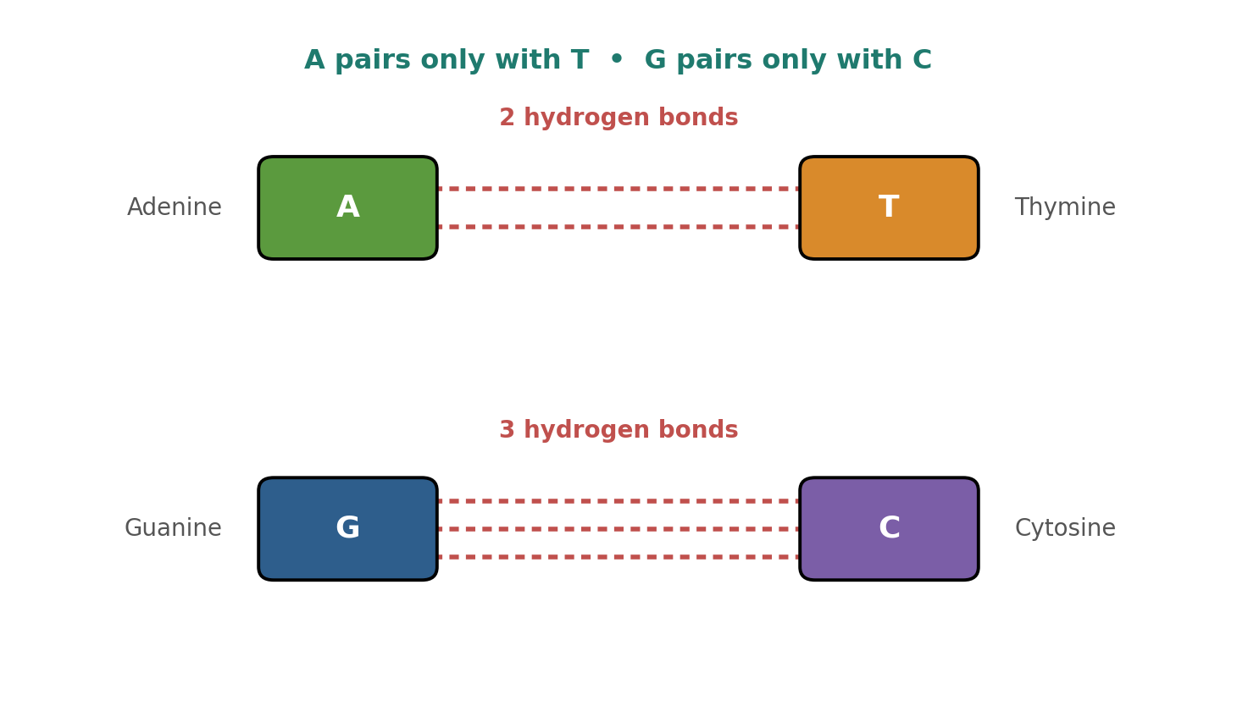

Figure 3 : Complementary base pairing and the hydrogen bonds that hold the two strands together.

From DNA to Chromosomes
DNA molecules are extremely long. If the DNA from a single human cell were stretched out completely, it would measure approximately two meters in length. Despite this, it must fit inside a nucleus that is only a few micrometers in diameter. To achieve this, DNA is carefully packaged into a highly organized structure.
The first level of packaging occurs when DNA wraps around proteins called histones. The DNA–histone complexes form structures known as nucleosomes, which are often described as "beads on a string." These nucleosomes help compact the DNA while also protecting it from damage.
The nucleosomes then coil and fold further to form a thicker structure called chromatin. As a cell prepares for division, the chromatin becomes increasingly condensed and tightly packed, eventually forming visible chromosomes.
This packaging process allows large amounts of genetic material to fit within the nucleus while keeping the DNA organized and accessible when needed for replication, transcription, and other cellular activities.
Human body cells contain 46 chromosomes arranged in 23 pairs, with one chromosome of each pair inherited from each parent. Together, these chromosomes contain the complete set of genetic information required for the growth, development, and functioning of the organism.

Levels of DNA Packaging

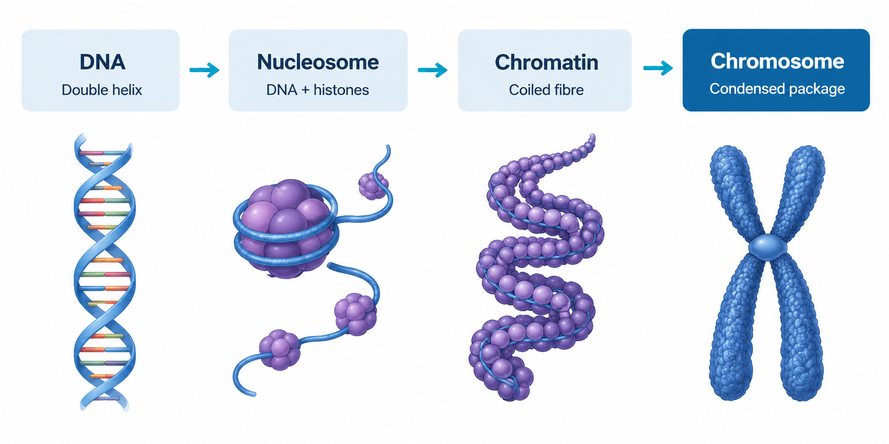

Figure 4: Levels of DNA Packaging
DNA is progressively packaged by wrapping around histone proteins to form nucleosomes, which coil into chromatin fibres and condense into chromosomes.

The organization of DNA into chromosomes ensures that genetic information remains protected, organized, and accurately distributed during cell division.

Why is DNA Packaging Important?
DNA packaging is essential because it allows extremely long DNA molecules to fit inside the small nucleus of a cell. Packaging also protects DNA from damage, keeps genetic material organized, and helps regulate which genes are active at particular times.
During cell division, chromosome packaging ensures that genetic information can be accurately distributed to daughter cells. Without efficient packaging, cells would be unable to manage and maintain their genetic material effectively.

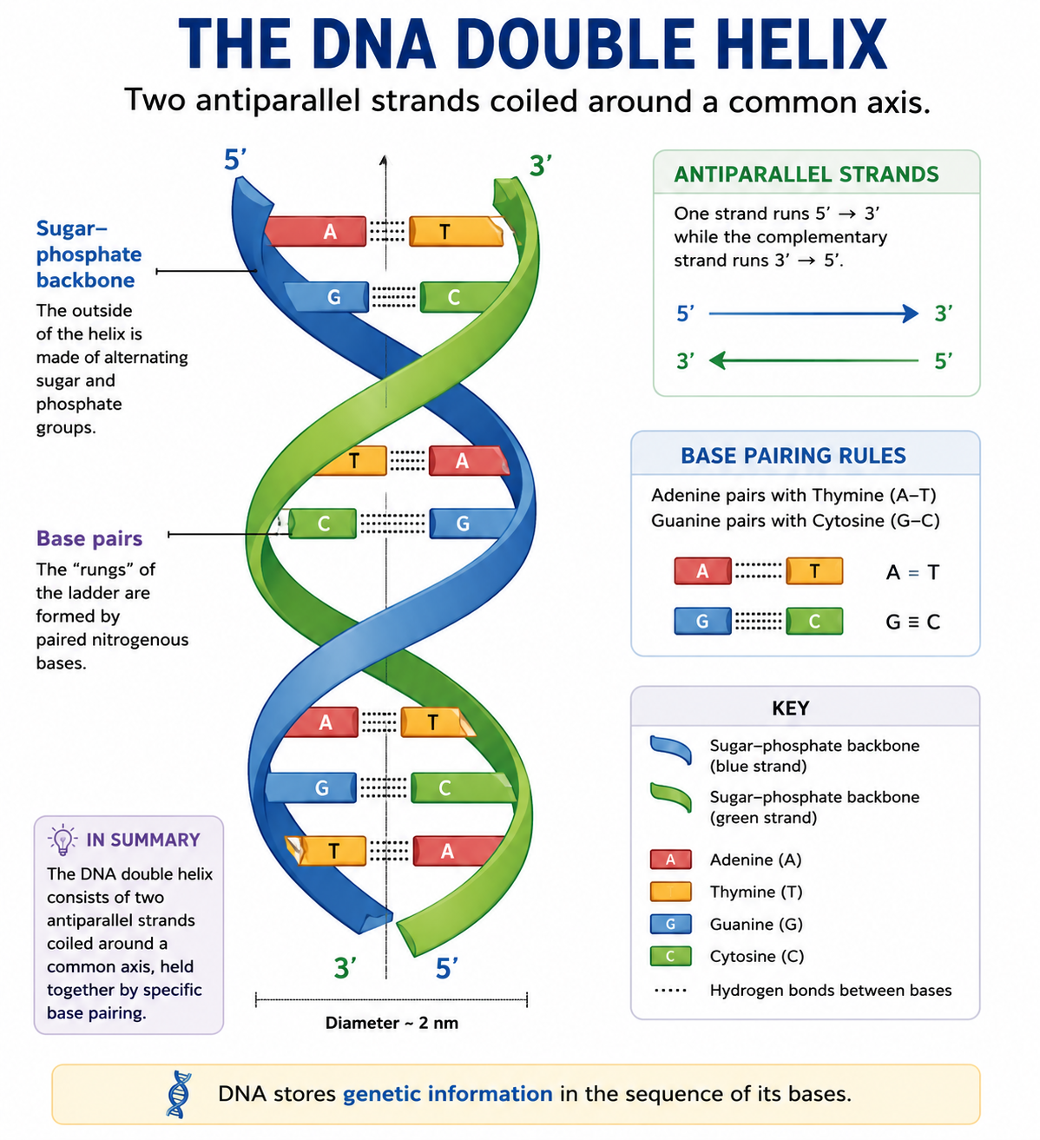

DNA Compared with RNA
Figure 5: DNA packaging - from double helix to a condensed chromosome.
Feature | DNA | RNA
Sugar | Deoxyribose | Ribose
Bases | A, T, G, C | A, U, G, C
Strands | Double-stranded (helix) | Usually single-stranded
Location | Mainly in the nucleus | Can leave the nucleus
Role | Long-term storage of information | Carrying & expressing information

Worked Example - Writing the Complementary Strand
One of the most important features of DNA is that the sequence of one strand determines the sequence of its complementary strand through the rules of complementary base pairing.
Consider the following DNA strand:
5′ – A T G C – 3′
Using the rules of base pairing:
- Adenine (A) pairs with Thymine (T)
- Thymine (T) pairs with Adenine (A)
- Guanine (G) pairs with Cytosine (C)
- Cytosine (C) pairs with Guanine (G)
Because DNA strands are antiparallel, the complementary strand must run in the opposite direction:
3′ – T A C G – 5′
This example demonstrates how complementary base pairing allows one DNA strand to act as a template for the formation of another strand. This property is essential for DNA replication and ensures that genetic information can be copied accurately from one generation of cells to the next.

Why DNA Structure Matters
The structure of DNA is closely linked to its biological function. Every feature of the DNA molecule contributes to its ability to store, protect, and transmit genetic information.
- Heredity - Complementary base pairing allows DNA to be copied accurately during replication, ensuring that genetic information can be passed from parents to offspring and from one cell generation to the next.
- Protein Synthesis - The sequence of bases within DNA forms a genetic code. Through transcription and translation, this information directs the production of proteins that control cellular structure and function.
- Genetic Stability - The double-helix structure protects genetic information while maintaining the stability required for long-term storage.
- Biotechnology - Understanding DNA structure enables scientists to analyze, copy, sequence, and modify genes for applications in medicine, agriculture, forensic science, and biotechnology.
- Modern Biological Research - Knowledge of DNA structure forms the foundation of genetics, genomics, bioinformatics, molecular medicine, and many other scientific fields.
By understanding DNA structure, scientists can better explain how genetic information is stored, inherited, and expressed, making DNA one of the most important molecules in all of biology.

PNG Context Example
Understanding DNA structure has practical applications in Papua New Guinea. Scientists use knowledge of DNA to study biodiversity, improve crop varieties, investigate inherited traits, and support agricultural and medical research.
For example, genetic studies can help improve disease resistance in crops and contribute to sustainable food production, while DNA analysis can support conservation efforts for native plant and animal species.

References & Related Documents

Source Documents
- STEM Biology Student Resource Book - Grade 12, Term 1. Module 12.1 Bioinformatics, Topic 1 (Nucleic Acids, Genes and Chromosomes). Department of Education, PNG (2021).
- Biology Standards-Based Syllabus, Grades 11 & 12 (PNG SBC 2020) - Strand 2: Life, Unit 2 Genetics; Benchmark 12.2.2.3.

Further Reading & References
- Alberts, B., et al. (2002). Molecular Biology of the Cell (4th Ed). Garland Science, New York.
- OpenStax Biology - https://openstax.org/books/biology
- National Human Genome Research Institute - https://www.genome.gov

